**FUNCTIONAL AND TECHNICAL COMBINED DOCUMENTATION**

**Page (41): Portfolio Action for Fixed Income (Front End Url:** http://localhost:8100/page41/Page41)

**Functional Picture:**

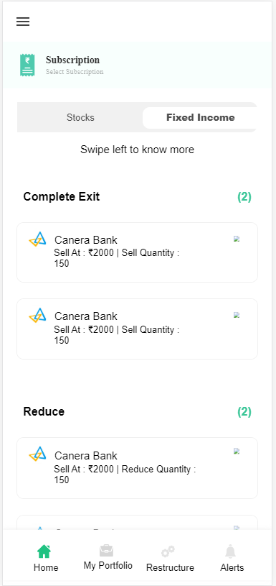

**This Page shows the Portfolio Action of Fixed Income Products.**

**Technical Explanation (Front End and Back End):**

**In Page41.tsx, we are calling following 4 API’s:**

1. CheckingNewUserExistingPortfolioUSerAPI: see backend python file. In this we are doing GET requests.
2. UserWithOrWithoutPortfolioFixedIncome: see backend python file. In this we are doing GET requests.
3. EverdayUserWithoutPortfolioFixedIncome: see backend python file. In this we are doing GET requests.
4. EverdayUserWithPortfolioFixedIncome: see backend python file. In this we are doing GET requests.

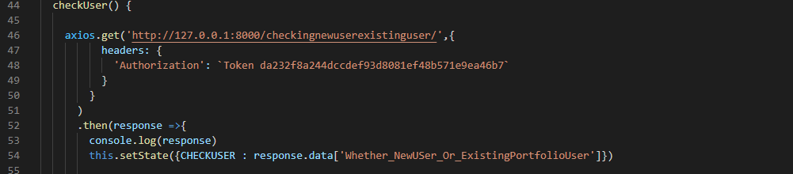

In the above given API, we are checking the type of the user.

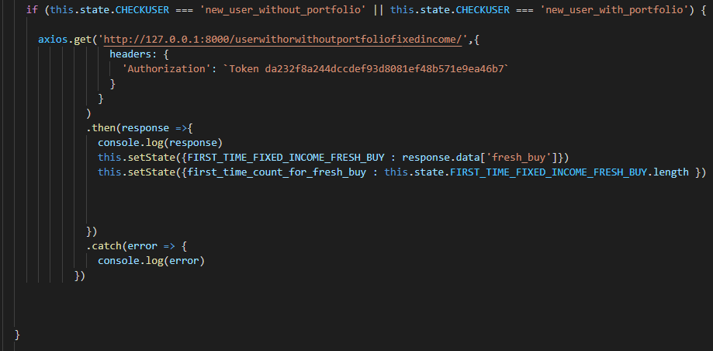

In the above given code snippet, you can see that we are calling UserWithOrWithoutPortfolioFixedIncome API. In this we are taking the FRESH BUY in the Fixed Income Securities. Kindly see the backend code

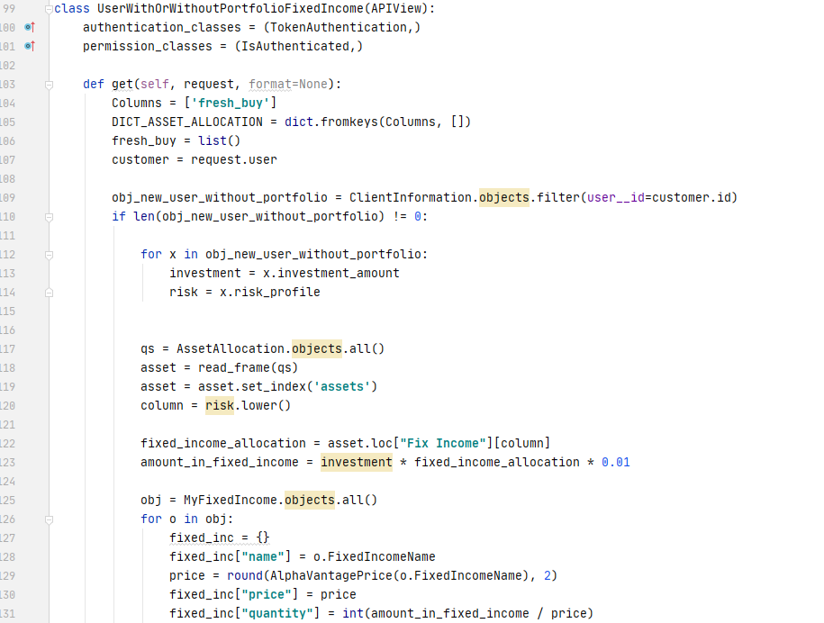



FIRST CASE: User is in this category “New User Without Portfolio“. First we will take his risk_profile and investment_amount. After that we will calculate the amount to be investment in this recommended fixed income security according to the Asset Allocation Table. Then we will be taking the fixed income security name from MyFixedIncome database and then calculate the quantity with the help of the price. And then we will send this to the front end to get display.

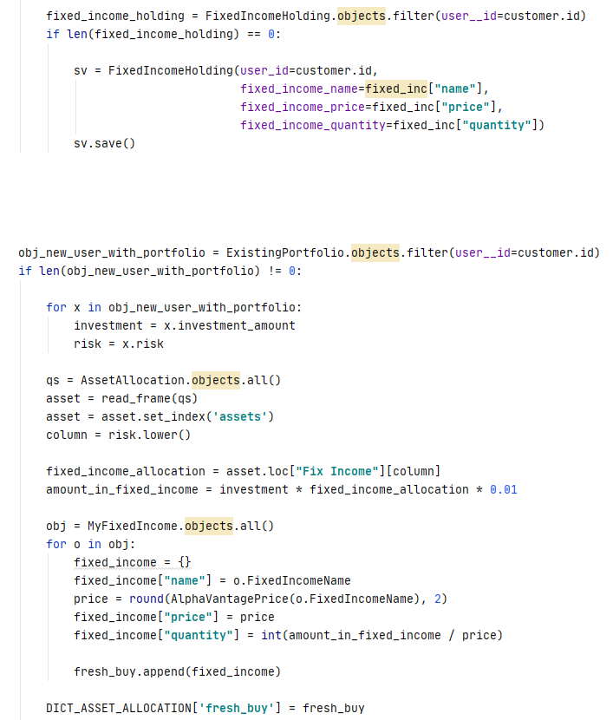

SECOND CASE: User is in this category “New User With Portfolio“. First we will take his risk_profile and investment_amount. After that we will calculate the amount to be investment in this recommended fixed income security according to the Asset Allocation Table. Then we will be taking the fixed income security name from MyFixedIncome database and then calculate the quantity with the help of the price. And then we will send this to the front end to get display.

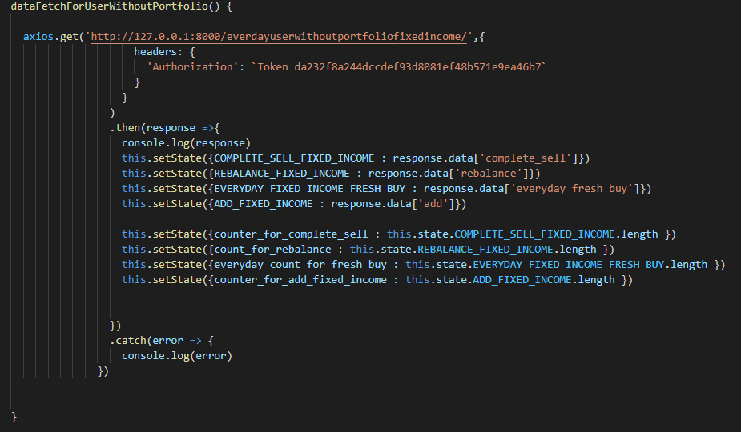

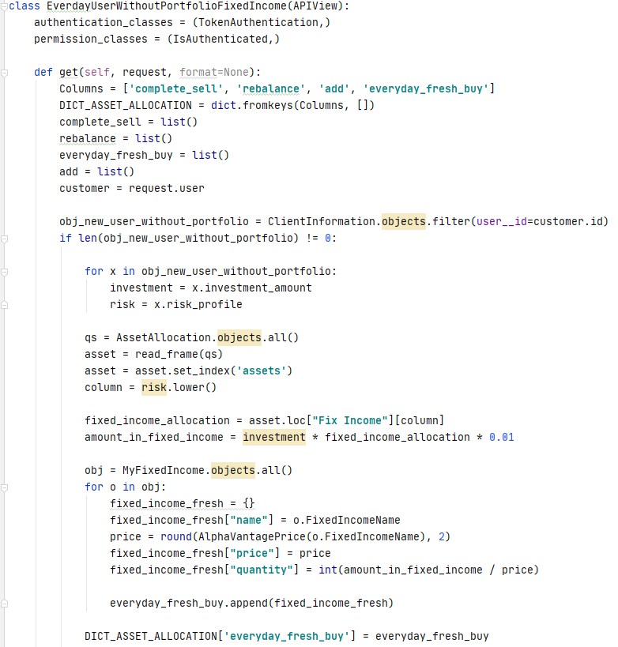

SECOND CASE: User is in this category “User without portfolio already existing “. For Everyday Fresh buy we will be doing the same procedure as we saw in previous cases.

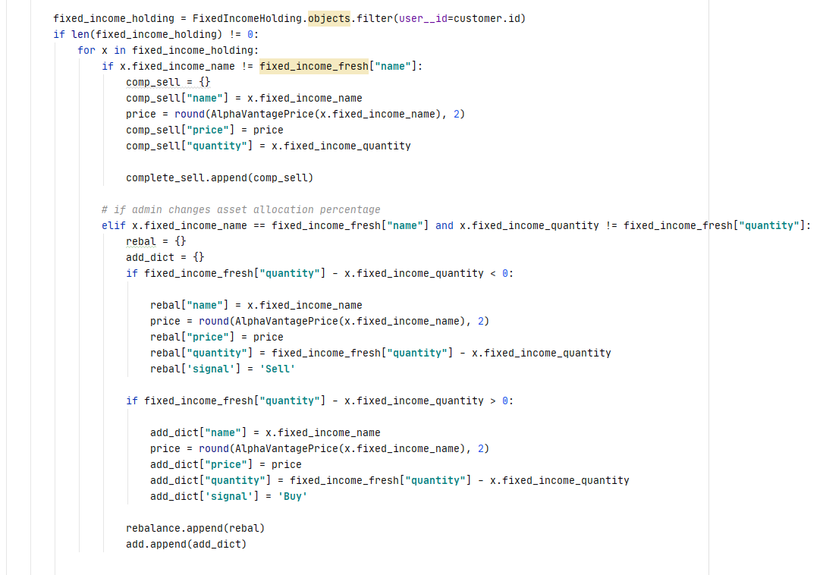

For Complete sell, if the fresh buy and the fixed income already existing then we have to sell the previous one and add the fresh one in our portfolio. The rebalance will happen if an admin changes some allocation parameters because we have to rebalance our fixed income portfolio according to the changed asset allocation parameters.

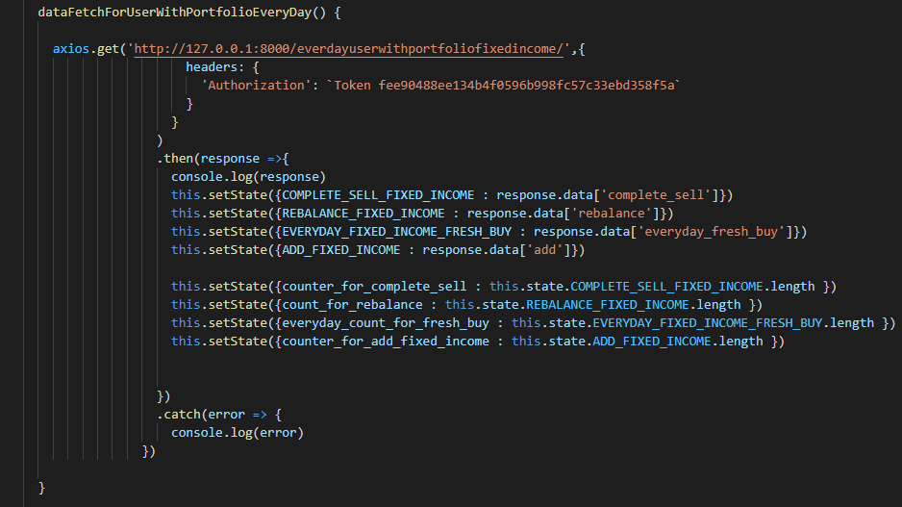

The backend code will be similar to that of EveryDayUSerWithoutPortfolioFixedIncome, the only difference in EveryDayUSerWithPortfolioFixedIncome is that in his we are ExistingPOrtfolio database to get the risk_profile and investment_amount.

**DONE!!!**